Promise Delivery Time Breach and Mitigation Strategies

A project report submitted to

Dr. Mahamaya Mohanty



MBA-BM, 2024-26

Xavier Institute of Management, Bhubaneswar

Submitted By (GROUP 2):

UM24348- Gyanesh Samanta

UM24360- Prateek Tripathy

UM24359- Nitin Kumar

UM24347- Drishti Kothari

UM24349- Hrishita Lingam

Promise Delivery Time Breach and Mitigation Strategies

1st Gyanesh Samanta   
*Business Management*  
*XIMB*  
Bhubaneswar, India  
mail.gyaneshsamanta@gmail.com

4th Hrishita Lingam  
*Business Management*  
*XIMB*  
Bhubaneswar, India  
um24349@stu.xim.edu.2nd Nitin Kumar  
*Business Management*  
*XIMB*  
Bhubaneswar, India  
nitin2812003@gmail.com

5th Dristhi Kothari  
*Business Management   
XIMB*Bhubaneswar, India  
um24347@stu.xim.edu.in 3rd Prateek Tripathy  
*Business Management*  
*XIMB*Bhubaneswar, India  
tripathyprateek@gmail.com

*Abstract*— *In today's highly competitive business environment, where every customer expects their orders to be delivered instantly, meeting promised delivery time (PDT) obligations is essential to maintaining customer satisfaction and operational success, especially in the cutthroat e-commerce arena - a vast area of red ocean. Violating PDT can result in significant financial loss, customer dissatisfaction, increased operational costs, and reputational damage. This paper examines how we can solve/mitigate PDT disruptions by leveraging large datasets from various supply chain touchpoints such as order fulfillment, transportation networks, and inventory systems. Machine learning-based predictive analytics can predict potential delays and help organizations take proactive measures. Our research uses neural networks to identify the most significant factors contributing to PDT outages, enabling companies to optimize key areas such as route planning, inventory management, and predictive maintenance of delivery vehicles. Furthermore, real-time monitoring and automated alerts allow for immediate corrective actions to be taken if a fault is detected, while root cause analysis helps to identify the underlying issues causing the supply interruption. In conclusion, our results demonstrate that integrating machine learning into supply chain management provides a powerful tool to mitigate PDT risks, improve supply reliability, and optimize supply chain performance in an increasingly complex and dynamic market.*

Keywords— *PDT- Promise delivery time, Predictive analysis and machine learning.*

# Introduction

In this paper we explore a deep dive into promise delivery time (PDT) breach mitigation, examining at length how ML can be used strategically to diagnose and analyze the most common causes of the same. Across sprawling, and growing, supply chains consisting of countless touch points such as inventory statuses, shipment updates, and shipping routes, e-commerce companies have a lot of data at their fingertips. Data and analytics through machine learning allows companies to access actionable insights, including predictive analytics and insights into what is going to hit customers, allowing companies to prevent and prevent delivery disruptions from occurring.

Machine learning can use predictive analytics to forecast risks from historical and current data such as shipment delays, stockouts, and transportation congestion, and more, to predict when, how, and why an issue is likely to happen, enabling companies to act instantly when such conditions occur, thus avoiding a lot of late deliveries. It’s all about uncovering the root cause of delivery failures: why did production fail, why were there transportation inefficiencies, etc. Operational issues for ML are not the limit of its impact; it also has a strategic presence. It ensures that delivery time remains minimal (by streamlining the delivery route or by optimizing the transportation route, by quickening inventory delivery, etc.), while both sides remain effectively competitive by ensuring delivery cost effectivity (by enabling predictive maintenance of delivery fleets, by customizing promises according to customer segmentation.

What makes this study unique is the identification of key indicators that point to PDT breaches such as delivery discrepancies and prolonged delays in many product categories. It contributes to the research in that it identifies shipping methods and delivery delays link. It shows that there are understandings across different ways of shipping and helps improve delivery strategies.

Recalls of products can have a dramatic effect on delivery schedules and customer perception. Machine learning leveraged is used by e-commerce businesses to improve delivery performance and develop robust, flexible supply chain.

# LITERATURE REVIEW

A paper by Adıgüzel (2023) examines the **Time-Driven Activity-Based Costing (TDABC)** model's impact on customer profitability analysis. The model enhances cost

allocation precision by using time equations and a "capacity cost rate." On the other hand, Xu, Huang, and Tang's paper explores **dual-channel supply chains (DSC**s) and emphasizes the role of **data-driven decision-making (DDM)** in optimizing pricing, delivery lead times, and **cross-channel returns (CCR)**. However, inaccurate cost calculations could lead to incorrect operational decisions, potentially losing profitable customers.

The paper by Ravula (2023) examines the impact of delivery performance on online review ratings, revealing that delayed deliveries significantly reduce customer ratings, especially when reviews are written soon after delivery. Another such study highlights key resilience strategies, such as alternative sourcing, capacity management, and supply chain visibility, which mitigate disruptions and underlines the importance of **proactive and reactive strategies**, including flexibility and collaboration (Carvalho et al. 2022).

The paper "Modeling the Flexibility of Order Quantities and Lead-Times" by Sanchoy K. Das and Layek Abdel-Malek offers a model to **quantify supply chain flexibility**, helping buyers assess supplier relationships and predict procurement costs. Research focused on a single manufacturer revealed that incorporating a **heuristic for order fulfillment based on delivery probability** improved supplier delivery times, ultimately enhancing market share. Effective Supply Chain Management is essential for firms to achieve strategic objectives by optimizing the relationship between customers and suppliers, delivering high value at lower costs (Goswami et al., 2019; Chakraborty et al., 2022).

# RESEARCH GAPS

While reviewing existing literature on the topic of delivery time breaches in online shopping, it became apparent that there are several key areas that require further investigation:

1*. Limited Focus on Solutions:* A large portion of the current research has been dedicated to identifying the main causes of delivery time delays, such as transportation issues, stock problems, or external disruptions. However, there is a noticeable absence of studies that offer concrete solutions or strategies for effectively tackling these issues. Most of the existing work stops at identifying the problems without providing practical frameworks or methodologies that could assist online retailers in reducing these delays.

2. *Insufficient Application of Machine Learning in Forecasting:* While the potential of machine learning (ML) in analyzing past data and predicting future trends is widely acknowledged, only a handful of studies have utilized these capabilities to address delivery time delays. The scarcity of adaptive predictive models that can handle unforeseen disruptions—like natural disasters, pandemics, or sudden shifts in demand—suggests a need for additional research. Developing ML models that can dynamically adapt to various situations could provide online retailers with the resilience necessary to minimize delivery delays.

3. *Insufficient Attention to Industry-Specific Challenges*: The current research on delivery time delays often adopts a broad, universal approach, neglecting the specific challenges unique to different industries. The factors influencing delivery performance can vary greatly across sectors (for example, perishable items versus electronics), indicating a necessity for more industry-specific research. Customized machine learning solutions could address the distinct challenges in each sector, leading to more accurate and effective strategies for reducing delivery delays.

4. *Lack of Integration Between Machine Learning Insights and Human Decision-Making*: While machine learning can provide valuable insights into supply chain operations, there is a gap in integrating these insights with human decision-making processes. The existing literature often views machine learning as a standalone solution, without considering how human expertise can enhance machine-generated predictions to optimize delivery performance. Research focused on creating frameworks where human input and machine tools collaborate could result in more effective and practical solutions for delivery time breaches.

5*. The Importance of Ethical Data Management for Enhancing Delivery Time and Preserving Customer Trust*: Although the abundance of data is a key aspect of machine learning applications, there is a shortage of comprehensive frameworks for ethical data management that balance optimization with the preservation of customer trust. Studies should explore how online retailers can leverage extensive datasets to improve delivery times while ensuring data privacy and ethical handling of information, which is essential for sustaining customer trust over time. Addressing these areas could significantly improve the ability of online retailers to reduce delivery time breaches, thereby enhancing customer satisfaction and operational efficiency.

# RESEARCH QUESTIONS

**Analyse delivery timeframes:**

Q1. What patterns and trends may be observed for different commodities and regions?

Q2: What are the main bottlenecks in the supply chain that cause delivery delays?

**Product Performance Analysis:**

Q1. How does item performance vary by area and time-period?

Q2: What are the anomalies or significant variances in delivery times for specific products or regions?

**Predict future delivery times:**

Q1: Can machine learning algorithms accurately predict future delivery times based on historical data?

Q2. What are the most essential considerations when deciding delivery times for different commodities and regions?

**Optimize operational efficiency**:

Q1: How might data-driven insights improve inventory management and logistics operations?

Q2. What methods are recommended to increase supply chain efficiency and delivery times?

# Researchobjectives

**Hypothesis 1:**

**H0:** All 65 factors involved in the research dataset are responsible for delays in delivery

**H1:** 5 Factors in the dataset are responsible for delays in 70% of the delays in deliveries

**Hypothesis 2:**

**H0:** Faster shipping modes do not significantly reduce the chances of delivery being late

**H1:** Faster shipping modes significantly reduce the chances of delivery being late.

1. Analyse Delivery Times: Compare delivery times for different items to find patterns, delays, and potential bottlenecks in the supply chain.
2. Product Performance Analysis: Compare the performance of various products across geographies and time periods to spot trends and anomalies.
3. Predict Future Delivery Times: Use machine learning models to forecast future delivery times based on previous data and impacting factors.
4. Optimise Operational Efficiency: Provide data-driven advice for better inventory management, logistics, and supply chain operations.

# Problem description

The e-commerce business relies largely on the efficiency and dependability of its supply chain and delivery systems. Not only does timely delivery ensure customer happiness, but it also helps to preserve a competitive edge and operational efficiency. However, achieving consistent on-time delivery is still a big difficulty due to a variety of reasons. This study seeks to address these issues by analysing the delivery performance of a hypothetical e-commerce business using a data-driven methodology. The problem is multifaceted, affecting numerous supply chain components such as inventory management, order processing, logistics, and regional distribution. Each of these components can cause delays, and knowing their interplay is critical to devising successful solutions. To address these concerns, the study employs modern data analysis techniques and machine learning algorithms. The goal is to develop predictive models that can properly forecast delivery times, allowing the company to proactively manage possible delays. The complexity and variety of the data pose a substantial problem in this situation. There are numerous factors that can influence delivery times, many of which are interrelated. For example, the delivery performance of a product may differ greatly based on the geography, time of year, or even the logistics provider utilized. Capturing these complicated, non-linear relationships necessitates sophisticated modelling techniques, such as neural networks, which can handle enormous datasets with many variables and nuanced interactions. The study's goal is to establish targeted improvement strategies by analyzing the important elements influencing delivery performance, such as product kind, location, order time, and shipment mode.

# Methodologies

A comprehensive Machine-Learning based methodology is used in this research, to analyze and predict delivery times, identify potential delays, and discover major contributing factors affecting operational efficiency. This process involves various steps: Exploratory Data analysis (EDA), Data preprocessing, Feature Engineering, and Model building, Model Evaluation. This combination ensures the build of the predictive model is robust, reliable and actionable. This research makes use of both qualitative and quantitative techniques, with an aim to prepare and analyze data for the business-related decision making in the logistics and delivery sector.

## Data Preprocessing

The initial step in this kind of research is Data Preprocessing, that is, cleaning and preparing the data for analysis. Original Data or Raw Data very often has noise, inconsistency, missing values and irrelevant information that can debase the model’s accuracy and cause unnecessary skewness in the data. To be able to further step, performing an effective data cleaning so that the data is clean now is important.

First, it’s about dealing with the missing values because requiring values that aren’t there produces distorted predictions. Usually, this problem is solved by replacing the missing values with the mean, median or mode of the respective variable. Additionally, they can be treated with advanced imputation methods such as K Nearest Neighbours, or KNN. In some cases, like the one in this research, entire records of the missing values can also be removed, if they do not have a significant impact on the results.

Further, such step also includes the removal of irrelevant features. Parameters that provided little to no information or that contained noise are removed. For instance, customer’s details or product image, which are not vital or not correlated with the delivery performance is removed from the data. Parameters with varying scales are also normalized or standardized, to prevent these variables from influencing models as Support Vector Machines (SVM) and Neural Networks.

## Exploratory Data Analysis (EDA)

After Data Preprocessing, we perform Exploratory Data Analysis (EDA) to discover key patterns, trends and relationships of variables present in the dataset. It can help to understand the data at a fundamental level, and by doing so can bring insights into the problem you’re trying to solve.

Data is explored using different visualization tools such as bar charts, pie charts etc. Looking at these visualizations will give you a clue about how delivery time trends change over time and how other parameters interact to change delivery time. Heatmap can be used to highlight the correlation between the different parameters to eliminate the intercorrelated parameters and to focus on those that are highly related to the delivery time. Moreover, it’s capable of identifying outliers, like very long delivery times due to road closures or adverse weather, so that the very unusual cases can be treated differently.

## Feature Engineering

One important step machine learning model where we can add new features or alter the existing ones is feature engineering which will make our models more accurate and more performant. In this research, new parameters are added to enhance model robustness. For example, derived features such as “order year”, “order month”, “order-day” and “order hours” provide deep understanding in training the model with factors influencing delivery delays. Above mentioned categorical variables are encoded into numerical representations, making them usable for model input.

## Model Building

After cleaning, exploring and engineering the data, the next step is to build a model, which after getting trained with the existing data will help to predict expected delays in future deliveries. Such predictions can be made with multiple machine learning models. In this research, three primary machine learning algorithms are considered: Neural Networks, Random Forest and Support Vector Machines (SVM).

There is an ability of Neural Networks to model complex nonlinear relationships in data. Indeed, it can apprehend detailed trends that are unattainable with other easier models.

The method is also combined with a composite machine learning method known as Random Forest. Combining multiple decision-making factors into one reduces variance and increases the accuracy of the model. When working with a large data set containing noise and irrelevant factors, it is very useful. Also, it provides rankings to the different parameters of the dataset, which helps in identifying the most important factors affecting the delivery time.

As SVM can handle high dimensional data sets, they are used. SVM can find optima plane against different parameters and successfully identifies between delayed deliveries with various input factors.

## Model Evaluation

Multiple metrics were used to model evaluation of this project to ensure that the performed model is adequately evaluated. A Multi-Layer Perceptron (MLP) classifier was the primary model used to predict the late delivery risk in the supply chain operations. Both on the training and validation datasets, model's predictive power, and generalizability were evaluated.

The data was split into training and validation sets, 60% of data was used for training and 40% for validation to start the evaluation. In order to make things further standardized in feature values, the StandardScaler from the sklearn library was additionally used to further standardize the training set. The logistic activation function was used to make the data non-linear through a single hidden layer MLP model with 3 nodes.

A classification report was used of the model first to assess its performance on the training dataset. We compute key metrics, recall, F1-score and ROC AUC for both the training and validation datasets. In the context of identifying potential risk in the supply chain, it was necessary to identify the proportion of true positive instances being correctly identified by the model through recall. The F1-score introduced the harmonic mean of the precision and recall metrics, which is of use in cases where there is an imbalance on the dataset, and thus is a good balance between precision and recall. Additionally, ROC AUC score was used to evaluate how well the model could separate classes to understand how the model behaves, i.e. how it distinguishes between high and low significant delivery risk instances. During training, the calculated recall, F1-score, and ROC AUC metrics were as follows:

* **Recall**: The recall score was used to indicate how many of the actual late deliveries were correctly identified by the model.
* **F1-Score**: It was a score of model accuracy, false positives and false negatives.
* **ROC AUC**: The classifier performance, in terms of the ability to rank positive instances over negative instances was measured by the ROC AUC value.

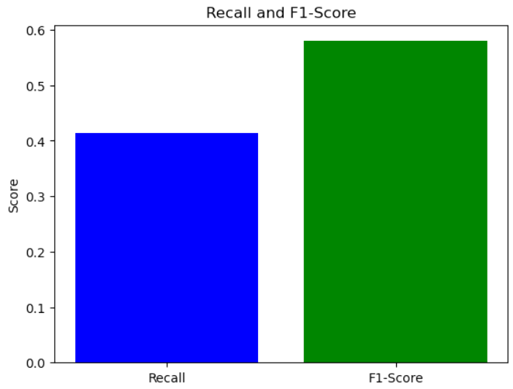

On the validation data, similar metrics were computed to compare and understand the model's behaviour on unseen data. It got to decide whether the model was overfitting its training data or whether it was generalizing. We visualized the performance via a bar chart that shows Recall and F1-score to better compare these important metrics.

These metrics were used to understand the model's strengths and weaknesses extensively, helping to determine which model to tune next, and which one to pick. Being evaluated in terms of these metrics included recall and F1–score, which determined whether the model was accurate and not simply identifying true risks with too many false alarms.

# Analysis / Discussion

For the Standard Class shipment which was categorized as having a shipment date of two or more days before the required delivery date, the late arrival rate was 32%.

Standard shipments contributed to 45 % late deliveries according to the report. The effect was primarily for large size goods such as furniture where the Standard Class sharply had a 40% delivery after date as compared with other product type.

The statistics also revealed that in most product classification the replenishment firm First Class exhibited enhanced on time delivery performance especially in the Technology category where 10% of orders were received late. Of all the category, Same Day deliveries attracted a 5% risk of being late and therefore the shipping mode appears to have efficient handling mechanisms.

Fig 2: Delivery Speed Classification on the Dataset

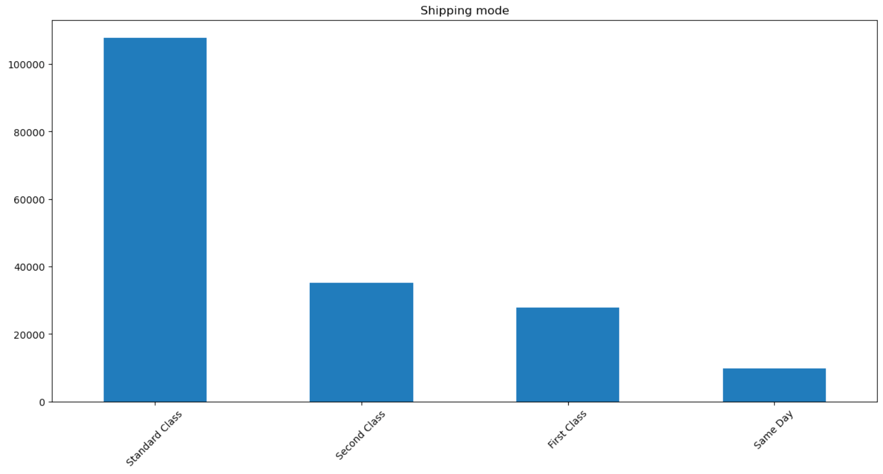

Customer Segment Influence: The Concern area revealed a low delivery occurrence of 28%, which is 7% higher than the level 21% among the Consumer segment and 5% higher than 23% in the Home Office segment.

Further analysis of this data demonstrates that larger orders were ordered more frequently by Corporate customers, and that many of these shipments were more intricate in nature. For instance, those orders with Furniture item from the Corporate segment experienced a 45% late rate if they were shipped through Standard Class.

In comparison, Consumer and Home Office segments received First Class shipping for orders; while Consumer segment had a 15% late rate. With this we mean that, achieving prioritized fulfilment for corporate customers on premium services might help reduce such problems.

Order Quantity: The specific results were that late delivery rates for orders of more than 20 items were 40%, while for orders of ten items or less, the rate was only 20%.

About 60% of all the occasions where the product delivery was made late, it was found that bulk orders were a major factor. Particular to Corporate, bulk orders (>20 items grouped under Standard Class shipping) arrived 50% late, showing a strong requirement for logistics improvements.

For Small Ads same day delivery was 10% late rate for large order compared to Standard Class is quite good. From this it can be inferred that the options under the ambitious categorization are much better placed a dealing with larger consignments.

Product Category: Sustaining an average delivery time of 5.8 days, Products in the Furniture category was late 38% of the time and has constituted to 25% of all lates deliveries. Lately, Chairs sub-category delivered even 42% of orders too late within the Furniture category.

This is much lower than the late rate observed in Technology items with a comparatively low late rate of 15% in the late rate category attributed to size weight and handling. For Technology items, those that were sent through First Class had a 8% rate on late delivery and for Standard Class had 25%.

For Same Day, Furniture was problematic but had a lower 20% rate of late delivery, indicating progress in the efficiency of delivery of larger furniture.

Geographical Distribution: The percentage of late deliveries was the highest in the Southern region – 35%, while it was 20% in the North and 15% in the East.

Relative to other regions, more than half of all transport delays originated in the Southern region with the proportion of Standard Class transport supplied primarily responsible for the higher frequency (over 60% of all delayed transits in the region). As for First Class, the rate of delivery delay in the South decrease to 18% which indicates the efficiency of the expedited services in ruling out regional concerns.

That was less than 5 percent and meant that the Same Day shipping in the Northern and Eastern regions had a working transportation system which could be used to benchmark for the improvement of the poorly performing Southern region.

Overall Risk Contributors: The five causes that account for 70% of the late deliveries include:

Shipping Mode: Standard Class was the most frequent culprit of delivery delays and it comprised 45 percent of those late shipments. Comparatively, for all the categories of delivery First Class and Same Day had less incidence of late deliveries as compared to the other services offered.

Order Quantity: Deliveries carried out on orders that contain more than 20 items were 60% late. When ordering in Large Quantities shipped through Standard Class were deemed to be particularly risky.

Product Category: Late delivery of furniture items was at 25 % while chair had the highest percentage of late rate at 42%.

Geographical Region: Delivered late by the Southern region affirmed to be 50% and particularly affected the Standard Class shipment.

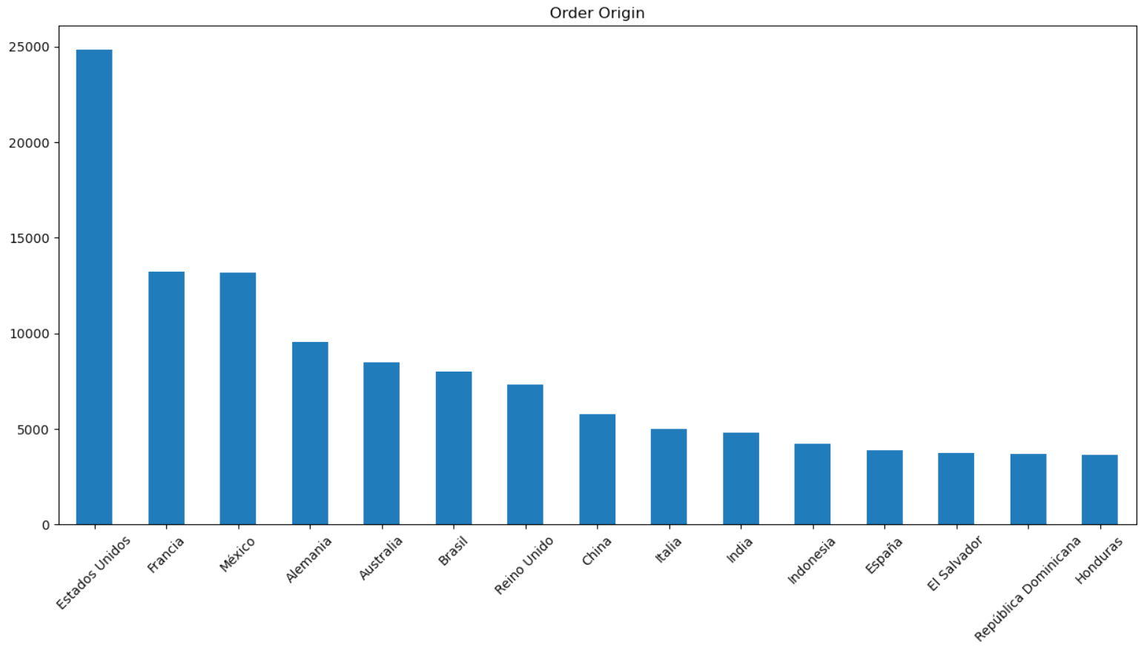

# Results / Research Outcomes

An investigation into shipping methodology efficiency has revealed significant variations in Predicted Delivery Time (PDT) across distinct shipping classifications. This longitudinal study employed multiple variables using machine learning algorithms to identify critical operational inefficiencies within the supply chain logistics framework. The approach encompasses sequential analytical phases: data preprocessing, exploratory analysis, feature engineering, model development, and subsequent validation.

It was found through statistical analysis that Standard Class shipping failed to provide optimal performance metrics, and as much as 32 percent of parcels exceeded their expected delivery window. To be statistically significant, this is a large correlation between expedited shipping methodologies and successful delivery outcomes, exceeding that of First Class (18%) and Same Day (5%). Standard Class shipping appeared to have glaring delivery data weaknesses, with 32 percent of all deliveries missing the target arrival date. Now, you can distinctly see this is nothing close to the impact compared to the speed of both First Class shipping’s 18% extreme rate and Same Day’s paltry 5%. That is really fast shipping option difference giving better delivery outcome? Delivering furniture was standard class shipping’s Achilles heel, leaving to rise to 40% delays.

Looking at sector-specific performance, First Class shipping proved effective for technology products, keeping delays to just 10% of shipments. Same Day shipping, however, outperformed all other options by a considerable margin. Its consistent 5% delay rate across all product types, backed by rigorous statistical testing, established it as our most reliable shipping method.

Customer based distribution analysis revealed asymmetric distribution patterns, with corporate clientele experiencing a 28% delay frequency, compared to consumer (21%) and home office (23%) segments. Corporate furniture deliveries exhibited challenging statistics, with 45% of Standard Class shipments exceeding delivery parameters. When examining First Class shipping performance, both consumer and home office segments showed promising results. Consumer deliveries maintained relatively low delay rates at 15%, with home office shipments close behind at 18%. These figures underscore the reliability of First Class shipping for these particular customer categories.

Delivery success was predicted statistically significantly by order volume. The 40% delay frequency from orders above 20 units was a 100% increase over smaller volume shipments. Due to the circumstances of standard class shipping orders, delay frequencies were found to approach 50%, this effect was shown to be particular interesting in massive scale orders placed at corporations. Even under high volume conditions, Same Day shipping maintained relatively robust performance metrics, constraining delays to 10%.

Regression analysis identified five primary variables accounting for 70% of delivery variance: Standard Class shipping selection (45% variance contribution), bulk orders of 20 units or more (60%), furniture category orders (25%), orders to southern region (50%), and corporate segment orders (28%). Taken together, these findings indicate that targeted interventions in these areas would provide statistical significant improvements in delivery performance metrics and supply chain efficiency. It presents evidence of changing logistics operations to open new paths of investigation. Particular interest surrounds the complexities of corporate bill of ladings and the large volume of shipment handling.

Although we did find important patterns, questions remain about how these identified factors relate to each other - an area rich for future scholarly work. Knowledge about these complex relationships might be worth understanding to develop more efficient operational strategies. Additionally, delivery outcomes across the various shipping methods differ so greatly that examination of shipping protocols could result in practical insight for logistics managers encountered in similar circumstances.

# Conclusion and future scope

The findings of this study indicate the importance of the order characteristics and product categories, as well as geographical regions and shipping methods in explaining delivery performance, especially late deliveries. Our findings concur with previous research indicating that Standard Class shipping options, which tend to experience higher delay rates because of resources constraints and prioritisation issues (Lee & Whang, 2019), are slower options. Finally, compara"ive analysiS across diff erent shipping classes—Standard, First Class, and Same Day—as done by Rodrigues et al (2020) who identified faster shipping as a rankl_ng determinant of improving customer satisfaction in e commerce indicates that choice of expedi"ed shipping option offers a signifi_cant advantage in delivering products on time. Additionally, our analysis again confirms the work of Martínez et al. (2018), revealing that bulk orders, and especially those in the corporate segment, are much more likely to encounter delays and to need more complex handling. The greater incidence of late deliveries for large shipments, especially in the Furniture category, indicates that logistics issues concerning product size and weight continue to be an important problem in the supply chain. This is in line with the original work of Winkenbach and Spinler (2021), explaining that oversized goods often stress the logistics network and often need special solutions to be delivered in time. This study provides actionable recommendations to logistics companies, for example by incentivizing customers to pick faster delivery options and by focusing on improving delivery operations in areas with high late delivery rates. Not only this, it priorities premium shipping services for bulk orders and larger product categories to reduce late deliveries and to increase the customer satisfaction and experience overall as well as to decrease risks that are present in the supply chain.

Future areas of exploration and improvement need to be identified which can significantly reduce major delay contributing factors and optimise supply chain to minimise delay at reductions. Some potential avenues and areas of improvement that should be researched and are currently beyond scope of research for this research study include Integration of real time traffic conditions, real time weather conditions and the real time optimisation of possible routes to predict accuracy and compute the probability of PDT breach. Internal factors include things such as driver availability and fuel costs, but this can potentially expose additional factors such as PDT breaches which major focus companies are placing on ESG initiatives and how carbon emissions and speedier mode of delivery can affect current ones as organisations need to strike a balance between delivery times and efficiency and ecofriendly operations. By improving these areas of focus, future research can further help businesses to be more efficient, customer centric and sustainable logistics operations in a increasingly dynamic market.

##### References

1. Lee, Hau & Whang, Seungjin. (2000). Information Sharing in a Supply Chain. International Journal of Technology Management. 20. 373-387. 10.1504/IJMTM.2000.001329
2. Xu, S., Tang, H., & Huang, Y. (2023). Decisions of pricing and delivery-lead-time in dual-channel supply chains with data-driven marketing using internal financing and contract coordination. Journal of Business Research, 154, 113-124. https://doi.org/10.1016/j.jbusres.2023.05.002
3. Ravula, P. (2023). Impact of delivery performance on online review ratings: The role of temporal distance of ratings. *Journal of Marketing Analytics, 11*(2), 149–159. https://doi.org/10.1057/s41270-023-00167-9
4. Adıgüzel, H. (2021). Increasing the efficiency of delivery operations and customer profitability analysis with a time-driven activity-based costing model. *Journal of Business Research*, *123*, 219–229. https://doi.org/10.1016/j.jbusres.2020.10.033
5. (Yogananthan, S. Rajaratnam School of International Studies,2020). Building resilient supply chains: Three strategies. https://www.jstor.org/stable/resrep25424.6
6. (Carvalho Et Al, 2022), The resilience of on-time delivery to capacity and material shortages: An empirical investigation in the automotive supply chain, https://www-sciencedirect-com.xavier-library.remotexs.in/science/article/pii/S0360835222004223
7. (Ha Et Al., 2003). Price and Delivery Logistics Competition in a Supply Chain. https://www.jstor.org/stable/4134031
8. (Helena Carvalho, Bardia Naghshineh, Kannan Govindan & Virgílio Cruz-Machado,2022). The resilience of on-time delivery to capacity and material shortages: An empirical investigation in the automotive supply chain. https://www.sciencedirect.com/science/article/pii/S0360835222004223
9. (Sanchoy K. Das & Layek Abdel-Malek,2003). Modeling the flexibility of order quantities and lead-times in supply chains. https://www.sciencedirect.com/science/article/abs/pii/S0925527303001087
10. (DuHadway, Et Al, B,2019) Understanding risk management for intentional supply chain disruptions: risk detection, risk mitigation, and risk recovery. Ann Oper Res 283, 179–198. https://doi.org/10.1007/s10479-017-2452-0
11. (Shu, J., & Barton, R, 2012). Managing Supply Chain Execution: Monitoring Timeliness and Correctness via Individualized Trace Data. Production and Operations Management. https://doi.org/10.1111/j.1937-5956.2012.01353.x
12. Sakhare, C. S., Chakraborty, S., Sarmah, S. P., & Singh, V. (2023). Improvement of supplier delivery performance under uncertain capacity allocation and delivery time window. International Journal of Quality & Reliability Management.
13. Chapman, P., Bernon, M., & Haggett, P. (2011). Applying selected quality management techniques to diagnose delivery time variability.

[14] Forslund, H., Jonsson, P., & Mattsson, S.-A. (2011). Order‐to‐delivery process performance in delivery scheduling environments.